Module 4

**Knowledge and Reasoning**

(4.1)

**Definition and importance of Knowledge** *(wampus on pg 20)*

* Knowledge can be defined as the body of facts and principles accumulated by human-kind or the act, fact, or state of knowing
* Knowledge can be considered as the distillation of information

that has been collected, classified, organized, integrated,

abstracted and value added.

Characteristics of Knowledge

• Knowledge is huge (Large in number or quantity).

• Knowledge is hard to characterize accurately.

• Knowledge differs from data in that it is organized such that it

corresponds to the ways it will be used.

• Knowledge is interpreted differently by different people.

**Issues in Knowledge Representation**

1. Important attributes

There are two attributes shown in the diagram, instance and isa. Since these attributes support inheritance, they are of prime importance.

2. Relationships among attributes

Basically, the attributes used to describe objects are nothing but the entities. However, the attributes of an object do not depend on the encoded specific knowledge.

3. Choosing the granularity of representation

While deciding the granularity of representation, it is necessary to know the following:

i. What are the primitives and at what level should the knowledge be represented?

ii. What should be the number (small or large) of low-level primitives or high-level facts?

4. Representing sets of objects.

There are some properties of objects which satisfy the condition of a set together but not as individual.

5. Finding the right structure as needed

To describe a particular situation, it is always important to find the access of right structure. This can be done by selecting an initial structure and then revising the choice.

[**Representation SystemKnowledge s**](https://www.javatpoint.com/ai-techniques-of-knowledge-representation)

There are mainly four ways of knowledge representation which are given as follows:

1. Logical Representation

Logical representation means drawing a conclusion based on various conditions. This representation lays down some important communication rules. It consists of precisely defined syntax and semantics

1. Semantic Network Representation

In Semantic networks, we can represent our knowledge in the form of graphical networks. This network consists of nodes representing objects and arcs which describe the relationship between those objects. Semantic networks can categorize the object in different forms and can also link those objects. Semantic networks are easy to understand and can be easily extended.

### Statements:

Jerry is a cat.

Jerry is a mammal

Jerry is owned by Priya.

Jerry is brown.

All Mammals are animals.

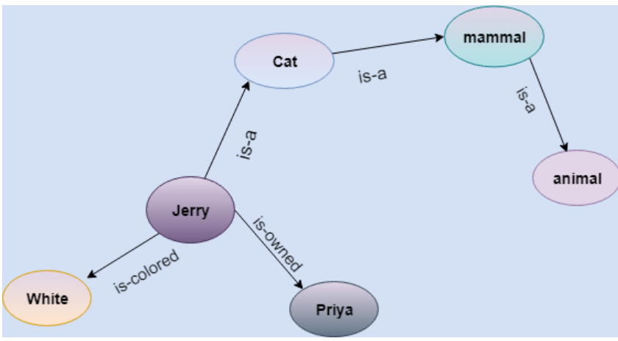

1. Frame Representation

A frame is a record-like structure which consists of a collection of attributes and its values to describe an entity in the world. Frames are the AI data structure which divides knowledge into substructures by representing stereotypical situations. It consists of a collection of slots and slot values. These slots may be of any type and sizes. Slots have names and values which are called facets.

**Facets** are features of frames which enable us to put constraints on the frames

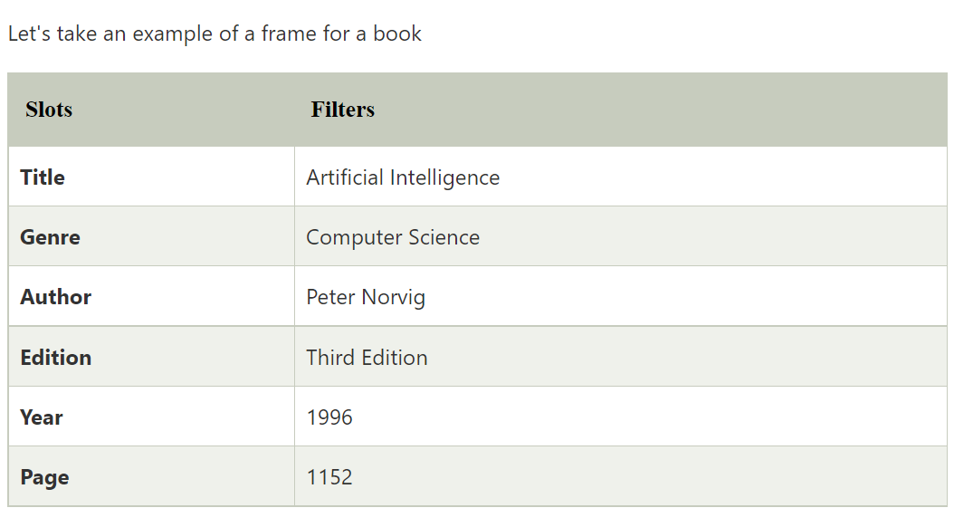

1. Production Rules

In production rules agent checks for the condition and if the condition exists then production rule fires and corresponding action is carried out. The condition part of the rule determines which rule may be applied to a problem. And the action part carries out the associated problem-solving steps. This complete process is called a recognize-act cycle

### Example:

* **IF (at bus stop AND bus arrives) THEN action (get into the bus)**
* **IF (on the bus AND paid AND empty seat) THEN action (sit down).**
* **IF (on bus AND unpaid) THEN action (pay charges).**
* **IF (bus arrives at destination) THEN action (get down from the bus).**

Properties of Knowledge Representation Systems

1. Representational Accuracy:  
   The KR system should have the ability to represent all kind of required knowledge.
2. Inferential Adequacy: (based on evidence)  
   The KR system should have the ability to manipulate the representational structures to produce new knowledge corresponding to existing structure.
3. Inferential Efficiency:  
   The ability to direct the inferential knowledge mechanism into the most productive directions by storing appropriate guides.
4. Acquisitional efficiency- The ability to acquire the new knowledge easily using automatic methods.

(4.2)

Propositional Logic (PL)-  *(sums on page 58 of ppt)*

Propositional logic is the simplest form of logic where all the statements are made by propositions. A proposition is a declarative statement which is either true or false. It is a technique of knowledge representation in logical and mathematical form.

A proposition formula which is always true is called tautology

A proposition formula which is always false is called Contradiction

Syntax-

It is a well-formed sentence.

The syntax of propositional logic defines the allowable sentences for the knowledge representation

Semantics-

A logic must also define the semantics or meaning of sentences. The semantics define the truth of each sentence with respect to each possible world.

For example, the semantics POSSIBLE WORLD for arithmetic specifies that the sentence “x + y = 4” is true in a world where x is 2 and y is 2, but false in a world where x is 1 and y is 1.

Formal logic-connectives-

Negation Conjunction Disjunction Implication Bidirectional

truth tables-

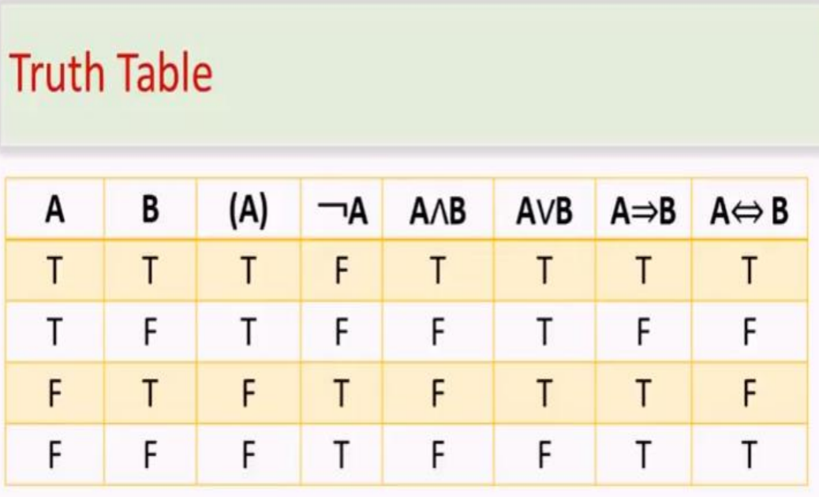

Tautology-

A tautology is a concept or statement that is valid in any significant manner in pure mathematics.

Validity-

A sentence is valid if it is true in all models.

e.g., True , A ⇒ A

Well-formed-formula-

Well-Formed Formula(WFF) is an expression consisting of variables, parentheses, and connective symbols.

Introduction to logic programming (PROLOG)

(4.3)

Predicate Logic: FOPL

First-order logic is another way of knowledge representation in artificial intelligence. It is an extension to propositional logic. FOL is sufficiently expressive to represent the natural language statements in a concise way. First-order logic is also known as Predicate logic or First-order predicate logic. First-order logic is a powerful language that develops information about the objects in a more easy way and can also express the relationship between those objects. First-order logic (like natural language) does not only assume that the world contains facts like propositional logic but also assumes the following things in the world:

* + Objects: A, B, people, numbers, colors, wars, theories, squares, pits, wumpus, ......
  + Relations: It can be unary relation such as: red, round, is adjacent, or n-any relation such as: the sister of, brother of, has color, comes between
  + Function: Father of, best friend, third inning of, end of, .....

Syntax-

The syntax of FOL determines which collection of symbols is a logical expression in first-order logic. The basic syntactic elements of first-order logic are symbols.

Semantics-

Quantification-

Inference rules in FOPL

Inference in First-Order Logic is used to deduce new facts or sentences from existing sentences.

**1. Universal Generalization**

* Universal generalization is a valid inference rule which states that if premise P(c) is true for any arbitrary element c in the universe of discourse, then we can have a conclusion as ∀ x P(x).
* It can be represented as: Inference in First-Order Logic.
* This rule can be used if we want to show that every element has a similar property.
* In this rule, x must not appear as a free variable.

**2. Universal Instantiation:**

* Universal instantiation is also called as universal elimination or UI is a valid inference rule. It can be applied multiple times to add new sentences.
* The new KB is logically equivalent to the previous KB.
* As per UI, **we can infer any sentence obtained by substituting a ground term for the variable**.
* The UI rule state that we can infer any sentence P(c) by substituting a ground term c (a constant within domain x) from **∀ x P(x) for any object in the universe of discourse**.
* It can be represented as:Inference in First-Order Logic

**3. Existential Instantiation:**

* Existential instantiation is also called Existential Elimination, which is a valid inference rule in first-order logic.
* It can be applied only once to replace the existential sentence.
* The new KB is not logically equivalent to the old KB, but it will be satisfiable if the old KB was satisfiable.
* This rule states that one can infer P(c) from the formula given in the form of ∃x P(x) for a new constant symbol c.
* The restriction with this rule is that c used in the rule must be a new term for which P(c ) is true.
* It can be represented as:Inference in First-Order Logic

**4. Existential introduction**

* An existential introduction is also known as an existential generalization, which is a valid inference rule in first-order logic.
* This rule states that if there is some element c in the universe of discourse which has a property P, then we can infer that there exists something in the universe which has the property P.
* It can be represented as: Inference in First-Order Logic
* **Example: Let's say that,**"Priyanka got good marks in English."  
  "Therefore, someone got good marks in English."

Forward Chaining-

* It is a down-up approach, as it moves from bottom to top.
* It is a process of making a conclusion based on known facts or data, by starting from the initial state and reaching the goal state.
* Also called as data-driven as we reach the goal using available data.
* Commonly used in the expert system, such as CLIPS, business, and production rule systems.

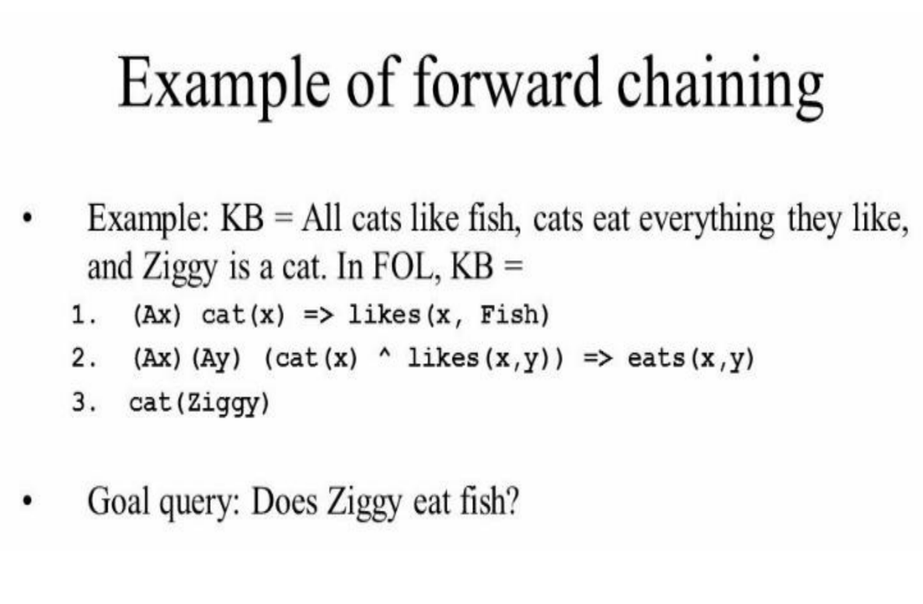

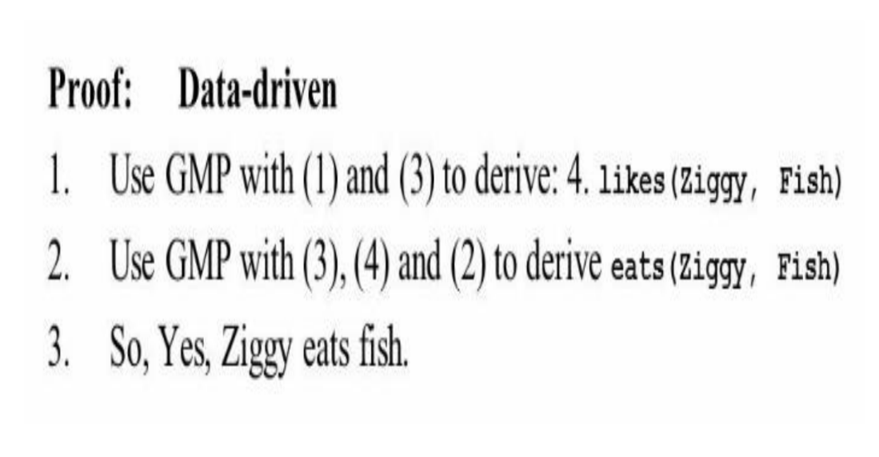

Backward Chaining-

A backward chaining algorithm is a form of reasoning, which starts with the goal and works backward, chaining through rules to find known facts that support the goal.

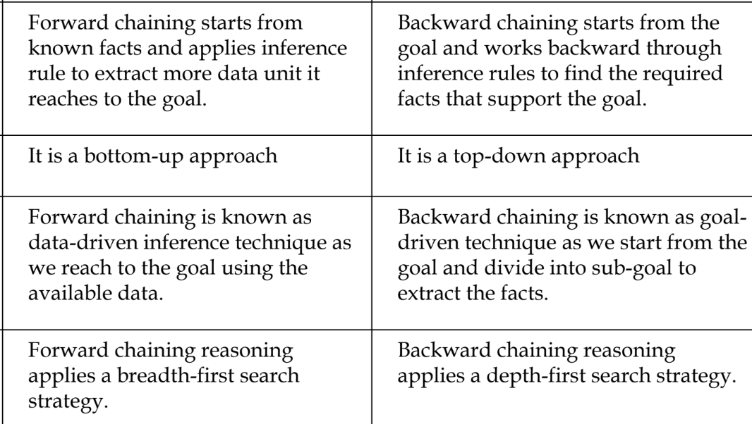

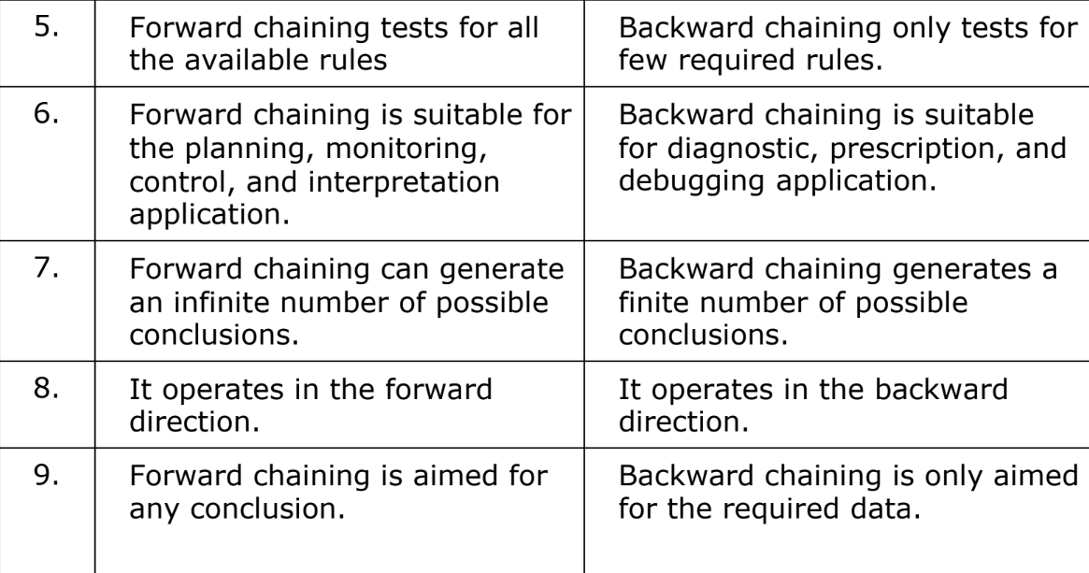

Resolution in FOPL-